LOCATION OF WTP

Kotarpur,Near Ahmedabad Airport,Ghanshyam Nagar,Naroda,Ahmedabad,Gujurat

LAYOUT OF WTP

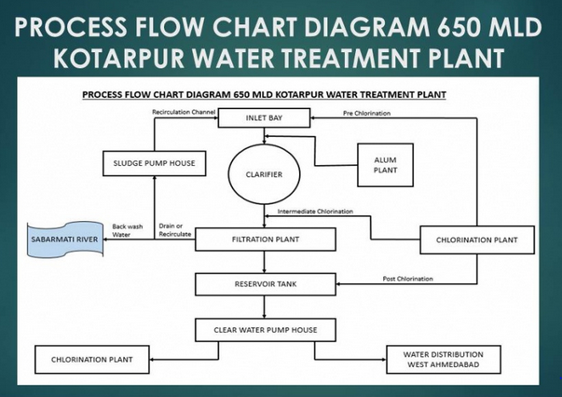

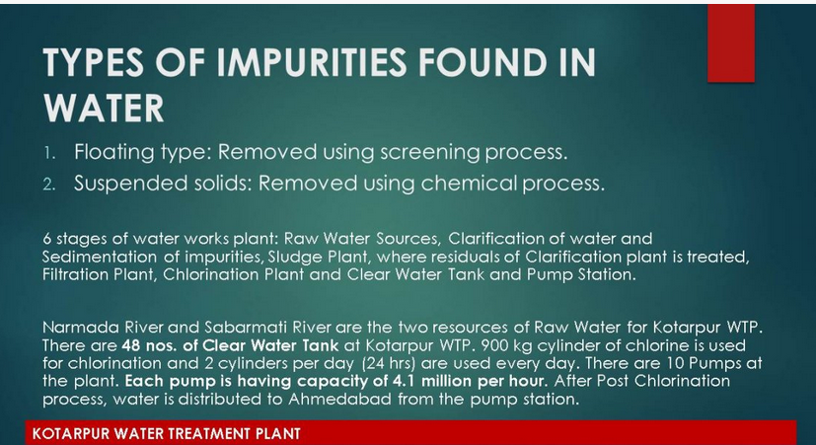

The beautiful part of entire plant is that it is run by entirely by gravity force thus saving lot of energy

CAPAPCITY OF WTP

**Kotarpur Water Treatment Plant** (WTP): **Kotarpur** WTP is the largest **water treatment plant** in Ahmedabad. The total **capacity** of existing **plant** is 850 Million Litres per Day (MLD) with the new **plant** having **capacity** of 200 MLD and the old **plant** having **capacity** of 650 MLD

Gujarat Chief Minister Vijay Rupani today dedicated Rs 62 crore water plant at Kotarpur near Ahmedabad airport. The new plant has 200 MLD capacity. It will save Rs 5.50 crore in power bill for Ahmedabad Municipal Corporation(AMC).

SOURCE FROM WTP

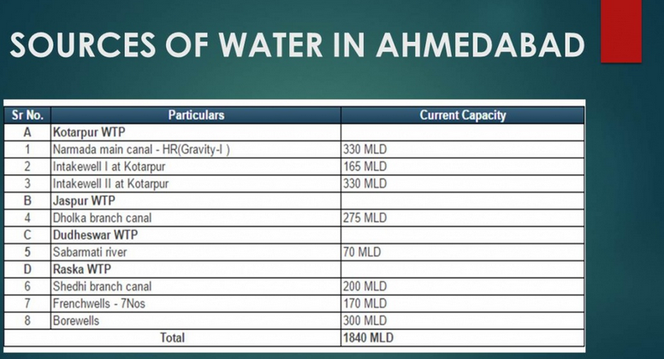

AMC has laid Rs 136 crore new gravity line upto Kotarpur from Narmada water source.

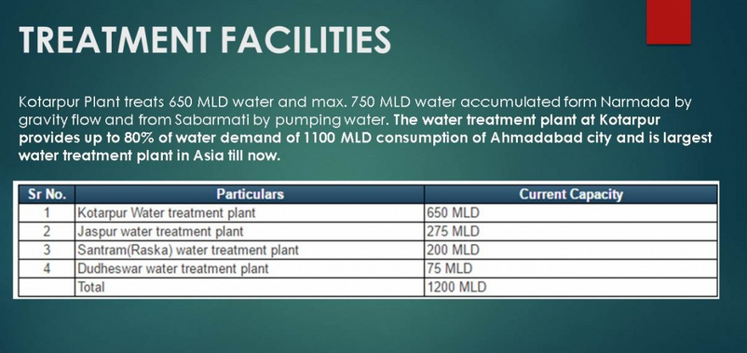

Treatment facilities
• There are two sewage treatment plants
• Pirana 180 mLd
• Vasana 180 mLd
• recently two sewage treat...

COMPENENTS OF WTP

ActivityA brief description about the entire plant was given by Mr. Nimesh Gajjar with the help of a water treatment plant model. It was followed by visit to

inlet bay,

Pump House,

Alum Dosing,

Clariflocculators,

Filtration Unit -filter bed, Filter house, Filter water pump House,

Disinfection Unit – Chlorine gas Dosing unit,

Sludge digestion unit- Sludge Handling Pump,

Clear water reservoirs & Pumps used for distribution system.

Let's start from beginning

1. Raw water source ( River, lake, impounding reservoir, canal)
2. Intake well
3. Jackwell
4. Raw water pumping system
5. Raw water conveyance system to Water treatment plant
6. Cascade areator
7. Parshel flume
8. Alum mixer
9. Intake channels
10. Carifier
11. Chemical house
12. Sand filters ( rapid gravity or pressure or both
13. Filter bed washing system
14. Back wash water recycling statem
15. Pipe gallery
16. Chlorine contact tank
17. Chlorine dosing system
18. Sludge removing system
19. Sludge thinking system
20. Sludge transfer pumps
21. Sludge ponds
22. Clear water reservoir
23. Clear water umping system
24. Flowmeter and valves
25. Scada and instrumentation system
26. Laboratory

LOCALITY WHERE IT SUPPLIES THE WATER

). Kotarpur plant supplies water to 60 lakh population of Ahmedabad which is spread in over 466 square km area

The city of Ahmedabad has 185 water distribution stations that are supplied water from Kotarpur, Jaspur and Rasta water treatment plants

Drinking Water - Quality
Our water supply comes from
two sources
• surface waters i.e. rivers,
lakes and reservoirs
• grou...

